ADS Assignment 1

Problem 5:

Dry Run & Analyze

Time and Space Complexity

1. Dry run the code
2. for n = 4. How many times is \* printed?
3. What is the time complexity?

void printTriangle(int n)

{

for (int i = 0; i < n; i++)

for (int j = 0; j <= i; j++)

System.out.print("\*");

}

Dry Run:

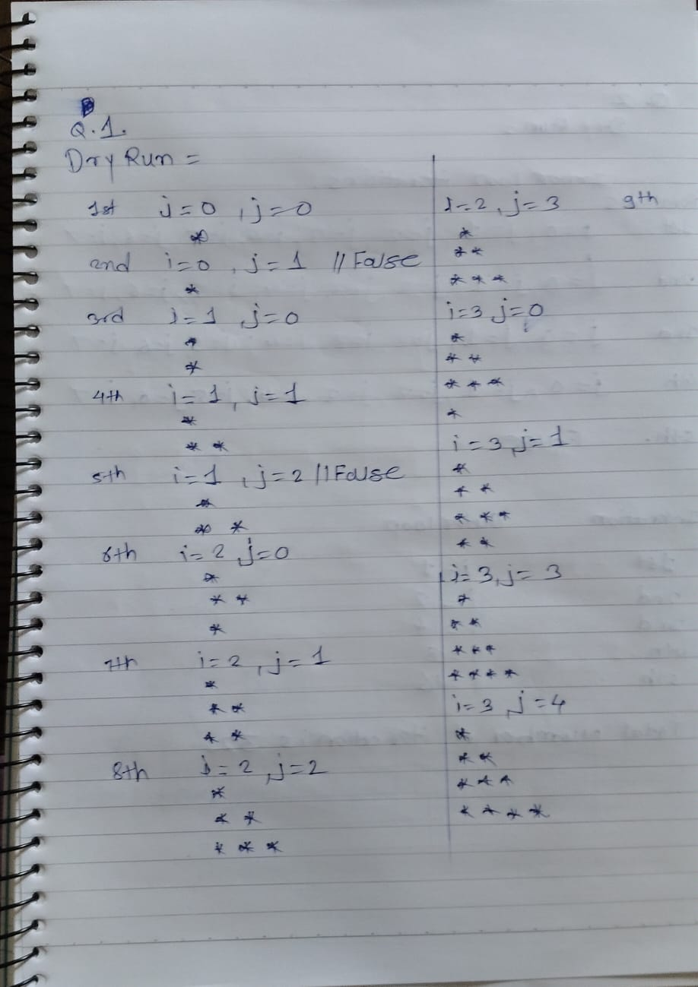

Time Complexity: O(n^2)

2. Dry run for n = 8.

What’s the number of iterations?

Time complexity?

void printPattern(int n) {

for (int i = 1; i <= n; i \*= 2)

for (int j = 0; j < n; j++)

System.out.println(i + "," + j);

}

Dry Run:

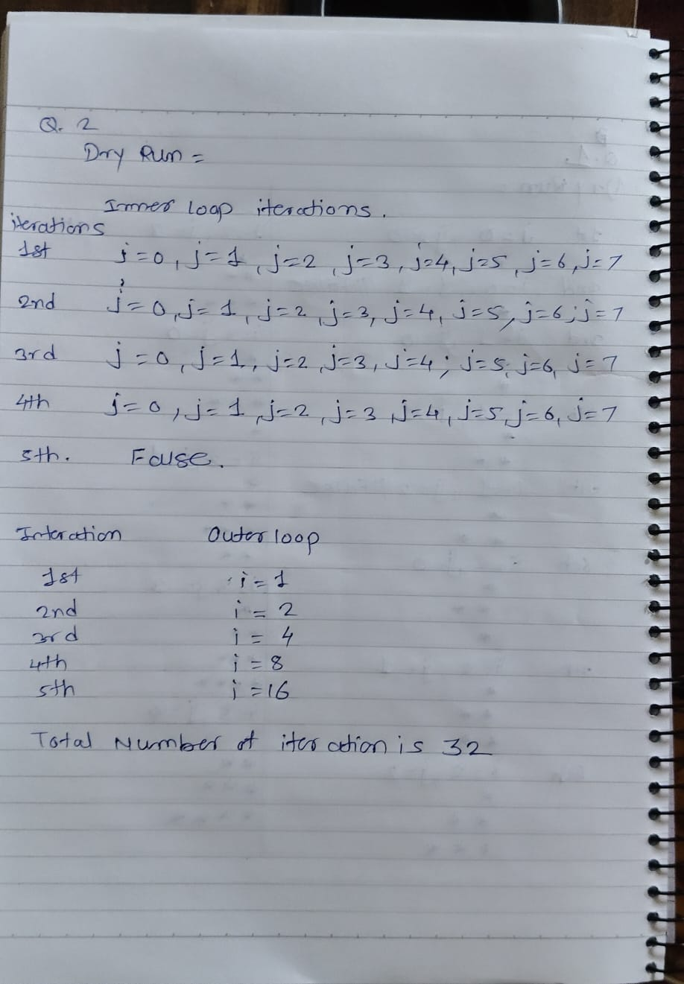

Time Complexity: O(n logn)

3.Dry run

for n = 20.

How many recursive calls?

What values are printed?

void recHalf(int n)

{ if (n <= 0)

return;

System.out.print(n + " ");

recHalf(n / 2);

}

Dry Run:

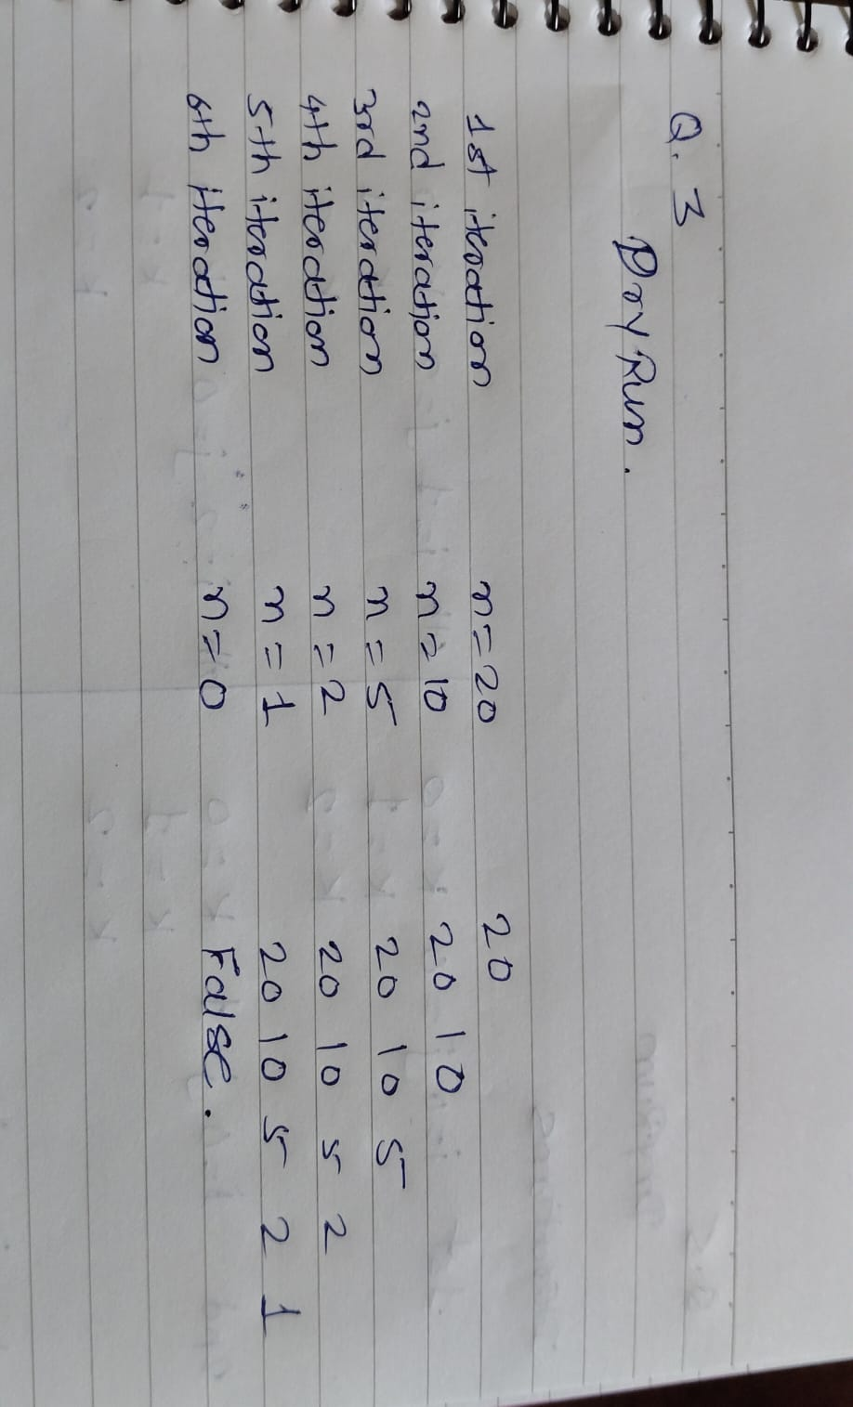

Time complexity:O(log2n)

4. Dry run for n = 3.

How many total calls are made?

What’s the time complexity?

void fun(int n) {

if (n == 0)

return;

fun(n - 1);

fun(n - 1);

}

Dry Run:

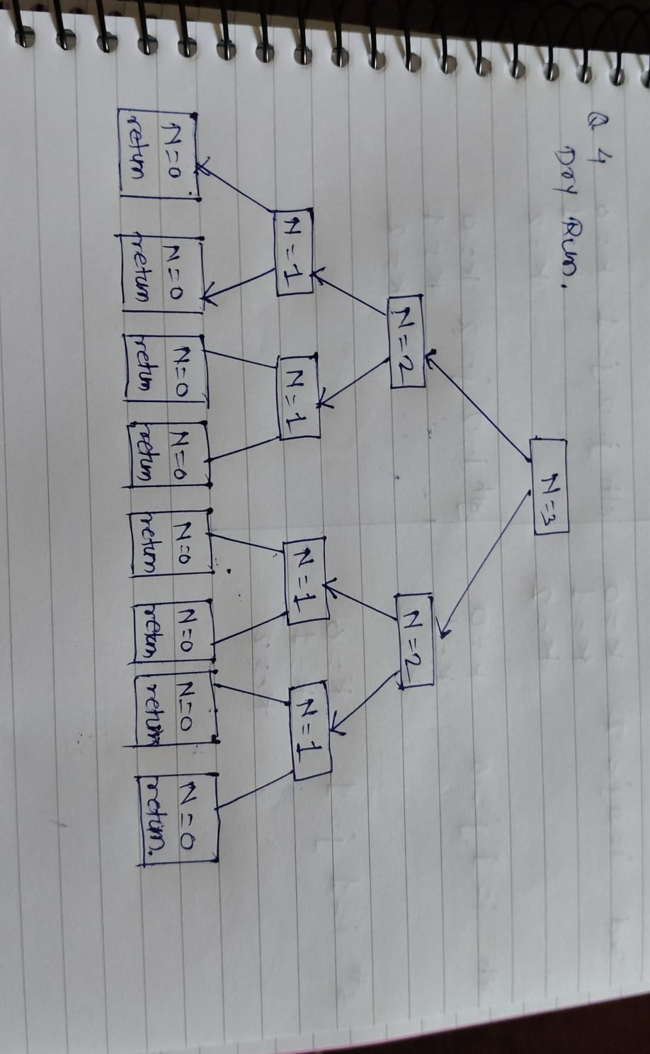

Time Complexity: O(2^n)

5. Dry run for n = 3.

How many total iterations?

Time complexity?

void tripleNested(int n) {

for (int i = 0; i < n; i++) for (int j = 0; j < n; j++)

for (int k = 0; k < n; k++)

System.out.println(i + j + k);

}

Dry Run:

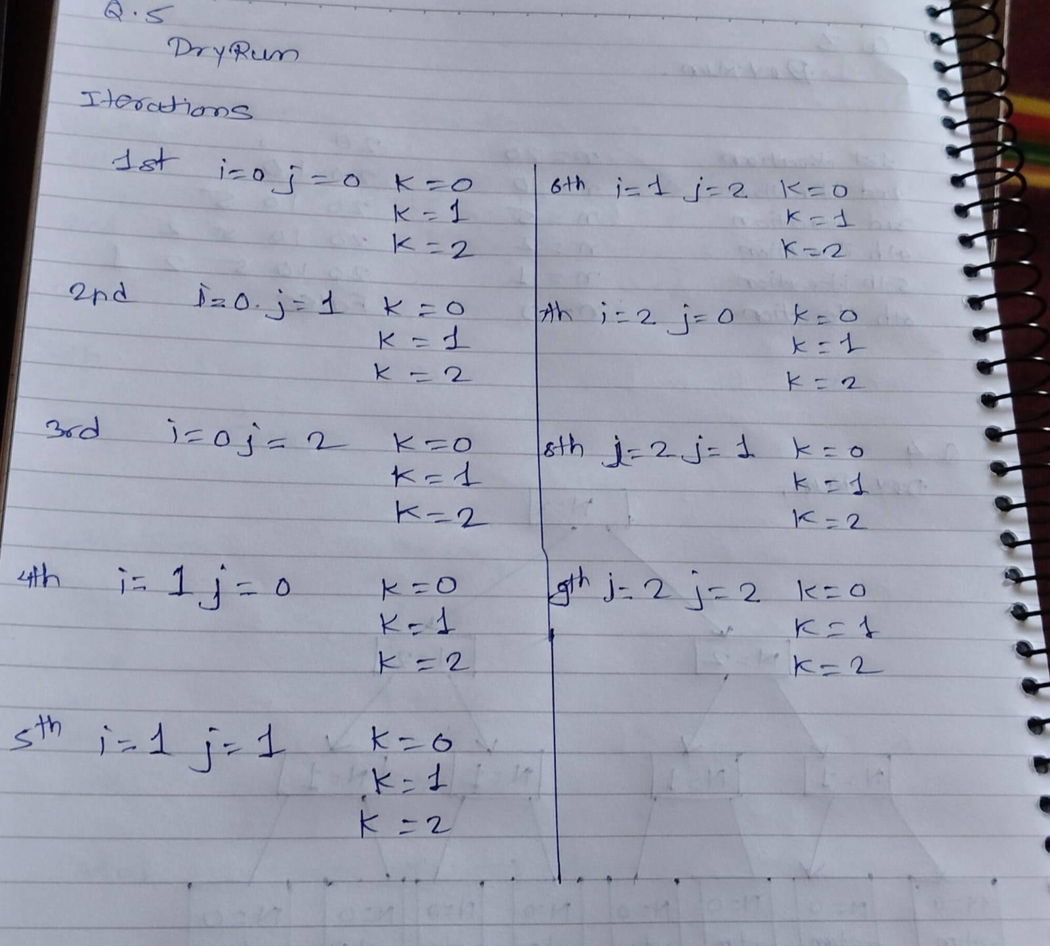

Time complexity:O(n^3).